Challenge description:

Give me the PIN, I'll give you the flag.

Solution

As the other time, we will use jadx, this time over the GUI for a change and just to make you see everything. You will see the following classes:
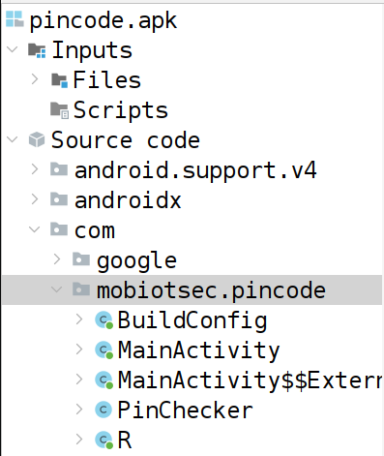

If you inspect the MainActivity, you see already a flag in clear:
public String getFlag(String pin) {
return "FLAG{in_vino_veritas}";
}

Inspect carefully the whole code: already, inside the onCreate there is a check over performance and check over pin widgets and a call to a strange symbolic with lambda, with an overly long name.
This seems associated with the click of a button, retrieves text from a widget and checks pin, validating the input pin and checking if flag matches.
There is also a strange external class, which reflects the long method name.

The other thing to be interested in is the PinChecker class, in which we can see an hashing of the pin using MD5 and if this is equal to a certain hash (d04988522ddfed3133cc24fb6924eae9) then it’s good; below there is a simple hex conversion into string function.

The important info we get is the PIN must be 6 chars:
public static boolean checkPin(Context ctx, String pin) {
if (pin.length() != 6) {
return false;
}

We know already MD5 is a hashing function and can take a lot of time to bruteforce properly; we will take the approach of taking the code, pasting it and executing it in order to see what then PIN can be. Maybe with bruteforcing we can be lucky (this is very time consuming, given has is a one way formula, so if you know the formula, you can bruteforce all numbers until you get close to the original number, but otherwise you can’t do much).

You can create a class like the following one:

import java.security.MessageDigest;

public class PinBruteForce {

public static void main(String[] args) {
String targetHash = "d04988522ddfed3133cc24fb6924eae9";

for (int i = 0; i <= 999999; i++) {
String pin = String.format("%06d", i); // Assuming 6-digit PIN
String hash = hashPin(pin);

if (hash.equals(targetHash)) {
System.out.println("Found PIN: " + pin);
break;
}
}
}

private static String hashPin(String pin) {
try {
byte[] pinBytes = pin.getBytes();
MessageDigest md = MessageDigest.getInstance("MD5");
for (int i = 0; i < 25; i++) {
for (int j = 0; j < 400; j++) {
md.update(pinBytes);
pinBytes = md.digest().clone();
}
}
return toHexString(pinBytes);
} catch (Exception e) {
System.err.println("Exception while hashing pin");
return null;
}
}

private static String toHexString(byte[] bytes) {
StringBuilder hexString = new StringBuilder();
for (byte b : bytes) {
String hex = Integer.toHexString(b & 0xFF);
if (hex.length() == 1) {
hexString.append('0');
}
hexString.append(hex);
}
return hexString.toString();
}
}

After almost 30 minutes (26 on my machine), you find:

Found PIN: 703958

If we implement in a class like this, you can see we find the correspondence and we call the flag correctly:

import java.security.MessageDigest;

public class HelloWorld {

public static void main(String[] args) {
// Example usage
String pin = "703958";

try {
byte[] pinBytes = pin.getBytes();
for (int i = 0; i < 25; i++) {
for (int j = 0; j < 400; j++) {
MessageDigest md = MessageDigest.getInstance("MD5");
md.update(pinBytes);
pinBytes = md.digest().clone();
}
}
boolean isValidPin = toHexString(pinBytes).equals("d04988522ddfed3133cc24fb6924eae9");
System.out.println("Is PIN valid? " + isValidPin);
if(isValidPin) {
System.out.println("Found Flag: " + getFlag(pin));
}
} catch (Exception e) {
System.err.println("Exception while checking pin");
}
}

public static String toHexString(byte[] bytes) {
StringBuilder hexString = new StringBuilder();
for (byte b : bytes) {
String hex = Integer.toHexString(b & 0xFF);
if (hex.length() == 1) {
hexString.append('0');
}
hexString.append(hex);
}
return hexString.toString();
}

public static String getFlag(String pin) {
return "FLAG{in_vino_veritas}";
}
}

To speed up the brute-force process using Java multithreading, you can parallelize the task by assigning different ranges of PINs to different threads. Each thread will be responsible for checking a subset of PINs, and this can significantly reduce the overall execution time.

